3D Shading Validation Scenes

May 2016

**Basic test 1**. Denver, CO. Lat/39.7392358 Lon/-104.9902510 Tz/-7

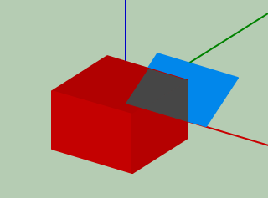

Two objects:

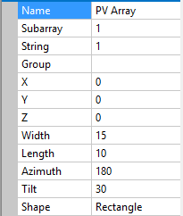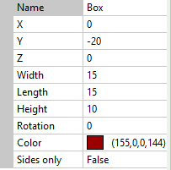

**Results.**

Diffuse shading: 8.78 %

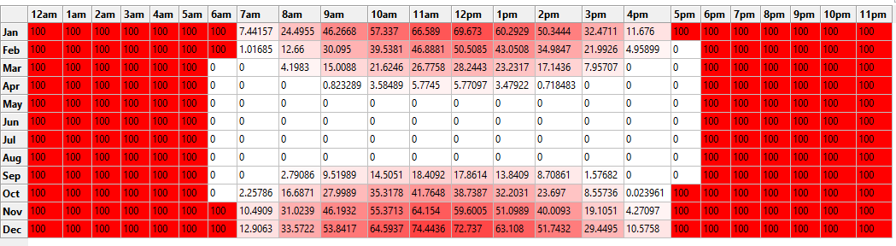

**Basic test 2**. Quito, Ecuador. Lat/ -0.1806532 Lon/ -78.4678382 Tz/-5

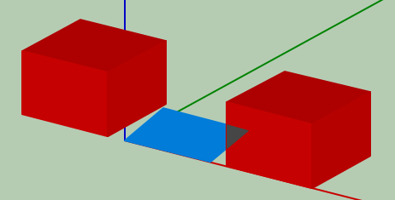

Three objects:

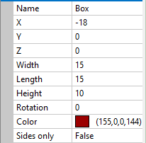 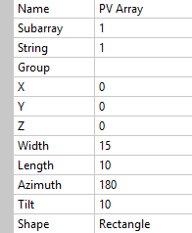 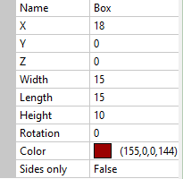

**Results.**

Diffuse shading: 16.82 %

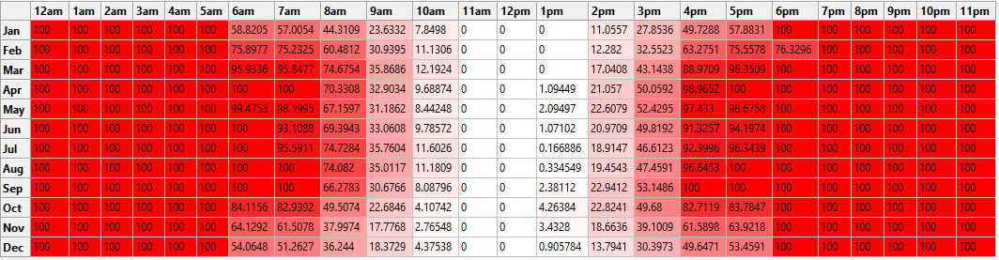

**Basic test 3**. Perth, Australia. Lat/ -31.9535132 Lon/ 115.8570471 Tz/8

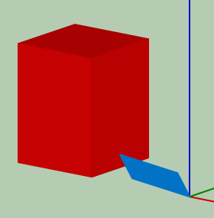

Two objects:

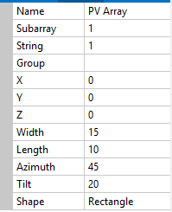 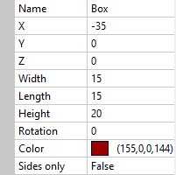

**Results.**

Diffuse loss: 8.1%

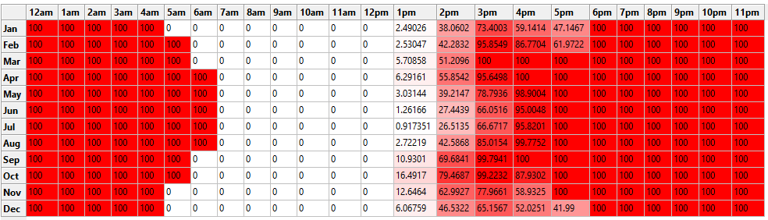

**Comparison with SunEye measurements for actual systems**

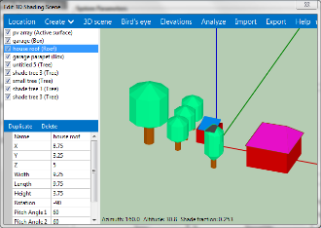

Figure. 3D shading scene for Ivanhoe

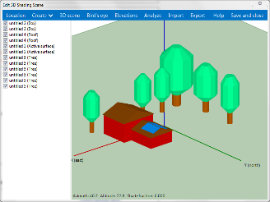

Figure. 3D shading scene for Babbitt

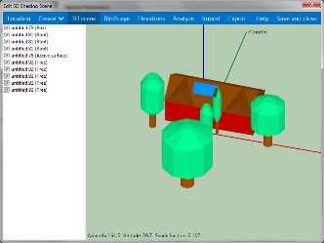

Figure. 3D shading scene for Halsted

|  |  |  |  |  |  |  |
| --- | --- | --- | --- | --- | --- | --- |
| **System** | **Location** | **System Size** | **Baseline kWh Annual** | **Lost energy (via SunEye)** | **Lost energy (via 3D)** | **Difference in energy loss estimates** |
| Ivanhoe | Denver | 3.6 kW | 5478 | 738 | 785 | 6.37% |
| Babbitt | Los Angeles | 4 kW | 5659 | 326 | 296 | 9.2% |
| Halstead | Los Angeles | 4 kW | 6427 | 361 | 329 | 8.86% |

**Possible Additional Systems:**

* Chris Deline’s house (need to get in touch with Chris)
* Trieu’s house (have suneye monthly solar access values)
* Steve’s shed?
* We have an old SunEye device. We could go make any sort of measurements whether or not there actually is a PV system and compare monthly solar access values.